

NATIONAL POLICE COMMISSION

**PHILIPPINE NATIONAL POLICE, POLICE REGIONAL OFFICE CALABARZON**

**CAVITE POLICE PROVINCIAL OFFICE**

**CARMONA MUNICIPAL POLICE STATION**

J.M. Loyola Street, Brgy. Maduya, Carmona, Cavite

November 2021

2021-11-467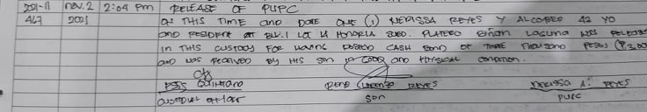

2021-11-472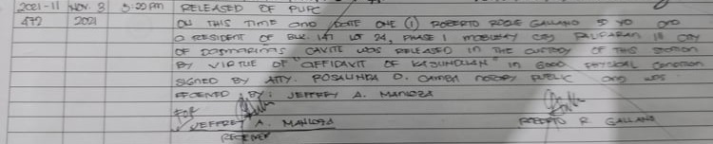

2021-11-478

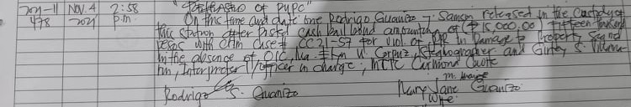

2021-11-480

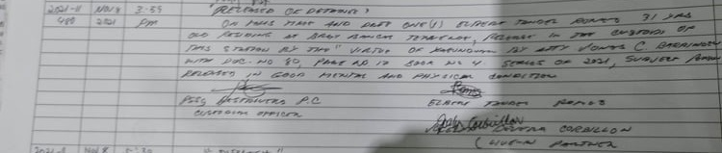

2021-11-486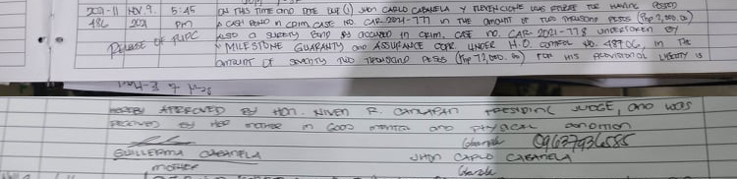

2021-11-492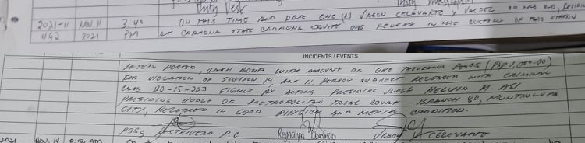

2021-11-496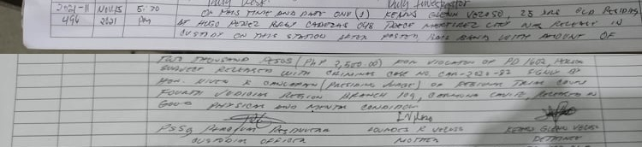

2021-11-497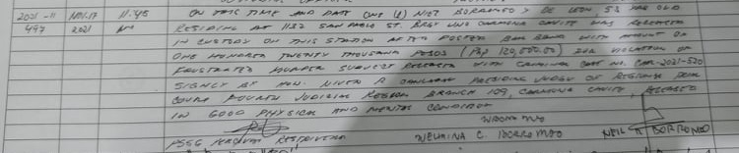

2021-11-499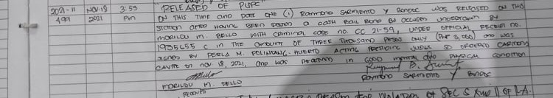

2021-11-510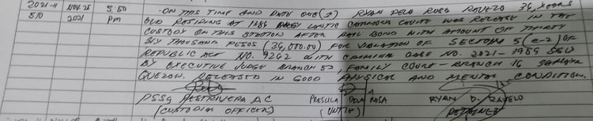

2021-11-514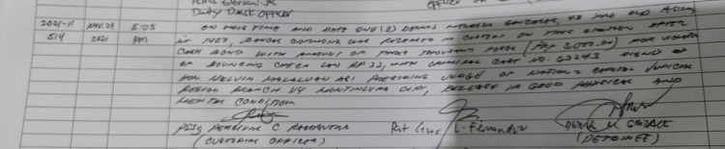

2021-11-517